Gymnastics for All – 776 Key Steps Competition 2018 Entrance Form
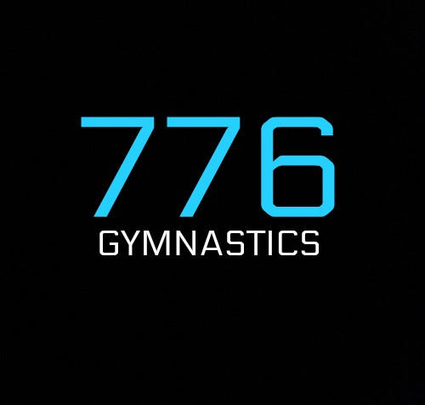
Hosted by 776 Gymnastics Academy

Please complete and return this entry form to jack.duggan@british-gymnastics.org

Competition details
Competition venue | 776 Gymnastics Academy
Time: | 9:30am | Date(s): |  | 30/09/2018
Competition organiser: | Jack Duggan |  | jack.duggan@british-gymnastics.org

Club details
Club/Team name: | [Insert name] |  | [Insert team name if different to club name]
Club contact name and number: | [Insert contact name] | [Insert contact number] |  | [Insert contact email]
Expected/estimated number of spectators: | [Insert estimate no. of spectators]

Judges’ details
Name | Most relevant judging qualification | BG no. | Contact no. | Emergency contact no.
[Insert name] | [Qualification] | [Insert BG no.] | [Insert no.] | [Insert no.]
[Insert name] | [Qualification] | [Insert BG no.] | [Insert no.] | [Insert no.]
If you can nominate more qualified judges that would be ideal to support the competition.

Coaches’ details
Name | Gender | BG no. | Contact no. | Emergency contact no.
Supervising coach
Must be BG Gold, Joint Gold or Life Member.
[Insert name] | [Gender] | [Insert BG no.] | [Insert no.] | [Insert no.]
Assisting coaches
Must be BG Silver (if level 1), Gold, Joint Gold or Life Member.
[Insert name] | [Gender] | [Insert BG no.] | [Insert no.] | [Insert no.]
[Insert name] | [Gender] | [Insert BG no.] | [Insert no.] | [Insert no.]
[Insert name] | [Gender] | [Insert BG no.] | [Insert no.] | [Insert no.]
Helpers
Don’t require membership but must be accompanied by a named coach (above) at all times.
[Insert name] | [Gender] | [Insert BG no.] | [Insert no.] | [Insert no.]
[Insert name] | [Gender] | [Insert BG no.] | [Insert no.] | [Insert no.]
A minimum of a supervising coach is required per team. BG coaching ratios still apply.
Entry payment details
Cost per competing gymnast: £10.00 per gymnast
Cost per spectator:
Adult | Child (under 16 years)
£4.00 | £4.00
Note: Spectator fees to be paid upon entry to competition and there is limited seating. Please speak with the competition organiser if you have a large group of spectators attending.
Cost for no allocated judge: £15
BACs transfer:
Name: | 776 Gymnastics
Account number: | 24270168
Sort code: | 30 – 91 – 91
Reference: | 776 Key Steps [Club name]
Please ensure the correct amount is paid upon entry. Without payment, entry will not be counted.

Gymnasts’ details
Gymnast name | Gender | Disability | D.O.B. | BG no. | Level
[Insert name] | Gender | Y / N | [Insert D.O.B.] | [Insert member no.] | Level
[Insert name] | Gender | Y / N | [Insert D.O.B.] | [Insert member no.] | Level
[Insert name] | Gender | Y / N | [Insert D.O.B.] | [Insert member no.] | Level
[Insert name] | Gender | Y / N | [Insert D.O.B.] | [Insert member no.] | Level
[Insert name] | Gender | Y / N | [Insert D.O.B.] | [Insert member no.] | Level
[Insert name] | Gender | Y / N | [Insert D.O.B.] | [Insert member no.] | Level
[Insert name] | Gender | Y / N | [Insert D.O.B.] | [Insert member no.] | Level
[Insert name] | Gender | Y / N | [Insert D.O.B.] | [Insert member no.] | Level
[Insert name] | Gender | Y / N | [Insert D.O.B.] | [Insert member no.] | Level
[Insert name] | Gender | Y / N | [Insert D.O.B.] | [Insert member no.] | Level
[Insert name] | Gender | Y / N | [Insert D.O.B.] | [Insert member no.] | Level
[Insert name] | Gender | Y / N | [Insert D.O.B.] | [Insert member no.] | Level
[Insert name] | Gender | Y / N | [Insert D.O.B.] | [Insert member no.] | Level
[Insert name] | Gender | Y / N | [Insert D.O.B.] | [Insert member no.] | Level
[Insert name] | Gender | Y / N | [Insert D.O.B.] | [Insert member no.] | Level
[Insert name] | Gender | Y / N | [Insert D.O.B.] | [Insert member no.] | Level
[Insert name] | Gender | Y / N | [Insert D.O.B.] | [Insert member no.] | Level
[Insert name] | Gender | Y / N | [Insert D.O.B.] | [Insert member no.] | Level
[Insert name] | Gender | Y / N | [Insert D.O.B.] | [Insert member no.] | Level
[Insert name] | Gender | Y / N | [Insert D.O.B.] | [Insert member no.] | Level
If you wish to enter additional gymnasts please complete another entry form.
Please list entries in order or level and age e.g. Level 1 – Age 5

Thank you

We are looking forwards to seeing you at our event

776 Gymnastics Academy

